

Industrial Defect Detection and Severity Analysis System

Name- Nisha
Reg. Number- 24BAI10441
Slot- B14 + D21
Faculty- Dr. Rajneesh Kumar Patel
Date of Submission - 18th September, 2026

1. INTRODUCTION

1.1 Background
Quality inspection is an essential part of modern manufacturing and industrial production. Manufactured products and raw materials must be inspected to identify surface defects and other abnormalities before they proceed to subsequent stages of production or reach the customer.
Traditional industrial inspection methods often depend on manual visual inspection. Although human inspection can identify many types of defects, it can become time-consuming and difficult to maintain consistently when a large number of products need to be inspected. Human inspection can also be affected by fatigue, lighting conditions, and differences in individual judgment.
The development of Artificial Intelligence and Computer Vision provides an opportunity to automate this process. An AI-based inspection system can analyze images of industrial surfaces and learn visual patterns associated with different types of defects.
The Industrial Defect Detection and Severity Analysis System is proposed as a computer-vision-based solution for analyzing industrial surface images. The system aims to identify the presence and type of defects, determine their location where applicable, and estimate their severity.

1.2 Motivation
The main motivation behind this project is to develop an automated visual inspection system that can assist in industrial quality control.
The system is designed to provide information such as:
- Defect presence
- Defect category
- Defect location
- Model confidence
- Defect severity
- Final inspection status
The project also provides practical experience in applying Artificial Intelligence, Machine Learning, Deep Learning, and Computer Vision to a real-world industrial problem.

1.3 Objectives
The major objectives of the project are:
- To develop an automated industrial image inspection system.
- To preprocess industrial surface images for AI-based analysis.
- To identify defective and non-defective surface regions.
- To classify defects into predefined categories.
- To localize defective regions where supported by the selected model.
- To estimate the severity of detected defects.
- To provide an understandable visual inspection result.
- To evaluate the performance of the developed model using appropriate metrics.
- To develop a modular system that can be extended with additional defect categories and models.

1.4 Scope
The scope of the proposed system includes image-based industrial surface inspection.
The system focuses on the following defect categories:
- Crazing
- Inclusion
- Patches
- Pitted Surface
- Rolled-in Scale
- Scratches
The system can be extended in the future to support additional defect types, industrial datasets, real-time camera feeds, and more advanced localization techniques.

2. PROBLEM STATEMENT
Industrial manufacturing processes may produce products containing different types of surface defects. Identifying these defects manually requires significant human effort and may become difficult when large numbers of products must be inspected.
The problem addressed by this project is to develop an AI-based industrial visual inspection system that can automatically analyze surface images and provide information about detected defects.
The proposed system should:
- Accept an industrial surface image as input.
- Validate and preprocess the input image.
- Detect whether a defect is present.
- Classify the defect into an appropriate category.
- Identify the defective region where applicable.
- Estimate the severity of the detected defect.
- Display the inspection result in a clear and understandable format.
The system is intended to demonstrate how Computer Vision and Artificial Intelligence can be applied to automate and assist industrial quality inspection.

3. FUNCTIONAL REQUIREMENTS
Functional requirements describe the operations that the system is expected to perform.
FR-01: Image Upload
The system shall allow the user to upload an industrial surface image for inspection.
FR-02: Image Validation
The system shall verify whether the uploaded file is a valid and supported image.
FR-03: Image Preprocessing
The system shall preprocess the input image before performing model inference.
Preprocessing may include:
- Resizing
- Normalization
- Pixel scaling
- Noise handling
- Image augmentation during training
FR-04: Defect Detection
The system shall determine whether the input image contains a detectable industrial defect.
FR-05: Defect Classification
The system shall classify the detected defect into one of the predefined categories:
No. | Defect Category
1 | Crazing
2 | Inclusion
3 | Patches
4 | Pitted Surface
5 | Rolled-in Scale
6 | Scratches
FR-06: Defect Localization
The system shall identify or highlight the defective region when the selected detection model supports localization.
FR-07: Severity Analysis
The system shall estimate the severity of the detected defect based on the implemented analysis method.
Possible severity levels are:
- Low
- Medium
- High
The exact severity criteria will depend on the final implementation.
FR-08: Result Visualization
The system shall display the inspection result, which may include:
- Predicted defect
- Confidence score
- Defect location
- Severity
- Processed image
- Inspection status
FR-09: Error Handling
The system shall display an appropriate message when:
- No image is uploaded.
- An unsupported file is uploaded.
- The image cannot be processed.
- A valid prediction cannot be generated.

4. NON-FUNCTIONAL REQUIREMENTS
Non-functional requirements define the quality characteristics of the system.
NFR-01: Performance
The system should process input images within a reasonable amount of time.
NFR-02: Accuracy
The model should provide reliable predictions for the defect categories represented in the training dataset.
Model performance will be evaluated using appropriate evaluation metrics.
NFR-03: Usability
The application should provide a simple interface through which users can upload an image and understand the inspection results.
NFR-04: Reliability
The system should provide consistent results for valid input images and handle invalid inputs appropriately.
NFR-05: Maintainability
The software should follow a modular architecture so individual components can be modified or replaced without affecting the entire system.
NFR-06: Scalability
The architecture should allow additional defect categories, datasets, and models to be added in the future.
NFR-07: Portability
The application should be capable of running on a standard computer system with the required software dependencies.

5. SYSTEM ARCHITECTURE
The proposed system follows a modular Computer Vision and Artificial Intelligence architecture.
5.1 Overall Architecture
The system consists of the following major components:
- User Interface
- Image Input Module
- Image Preprocessing Module
- Defect Detection Module
- Defect Classification Module
- Defect Localization Module
- Severity Analysis Module
- Inspection Engine
- Result Visualization Module

Architecture Flow
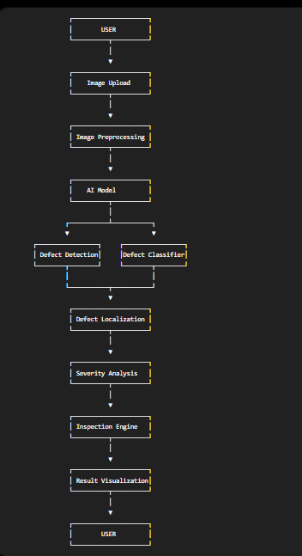

6. DESIGN DIAGRAMS
6.1 Use Case Diagram
Actor
User
Main Use Cases
- Upload Image
- Start Inspection
- View Prediction
- View Defect Category
- View Defect Location
- View Severity
- View Final Inspection Result
Use Case Representation
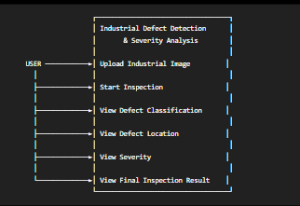Figure 1: Use Case Diagram
In the final PDF, create this as an actual diagram rather than leaving it as text.

6.2 Workflow Diagram
The workflow of the system is:
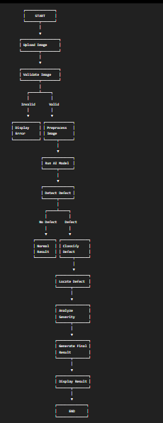
Figure 2: System Workflow Diagram

7. DESIGN DECISIONS AND RATIONALE
7.1 Use of Computer Vision
Computer Vision was selected because the primary input to the system is an industrial surface image. Visual characteristics such as texture, shape, edges, patterns, and regions can be analyzed computationally.
7.2 Modular Architecture
The system is divided into separate modules for preprocessing, detection, classification, localization, and severity analysis.
This approach makes the system easier to:
- Develop
- Test
- Debug
- Maintain
- Extend
7.3 Machine Learning / Deep Learning
AI-based models are used because industrial defects can have complex visual patterns that are difficult to describe completely using manually defined rules.
A trained model can learn relevant visual features from labeled training data.
7.4 Separate Severity Analysis
Severity analysis is treated as a separate component so that the system can provide information beyond simply identifying the defect category.
This allows the project to consider characteristics such as defect size, affected area, concentration, and model output.
7.5 Result Visualization
Visual output is included so that users can understand the model's prediction more easily.

8. IMPLEMENTATION DETAILS
8.1 Development Technologies
The proposed implementation uses Python and commonly used Computer Vision and Machine Learning libraries.
Technology | Purpose
Python | Main programming language
OpenCV | Image processing and computer vision
NumPy | Numerical operations
Pandas | Dataset/data processing
Matplotlib | Visualization
Scikit-learn | Machine learning and evaluation
TensorFlow/PyTorch | Deep learning model
Streamlit | User interface
The exact deep learning framework should be updated in the final report according to the framework actually used in the implementation.

8.2 Dataset
The system uses an industrial surface defect dataset containing multiple defect categories.
The planned defect classes are:
- Crazing
- Inclusion
- Patches
- Pitted Surface
- Rolled-in Scale
- Scratches

8.3 Data Preprocessing
The dataset is prepared before model training.
The preprocessing pipeline may include:
- Loading images.
- Checking image validity.
- Resizing images.
- Normalizing pixel values.
- Assigning labels.
- Splitting the dataset into training, validation, and testing subsets.
- Applying data augmentation where appropriate.

8.4 Model Training
The prepared dataset is used to train the selected AI model.
The training dataset is used to learn model parameters.
The validation dataset is used to monitor model performance during development.
The test dataset is kept separate and used to evaluate the final model.

8.5 Defect Classification
The classification module predicts the defect category associated with an input image.
The output can contain:
Predicted Defect: [Defect Class]
Confidence: [Actual Confidence]

8.6 Defect Localization
Where supported by the selected detection approach, the system identifies the region containing the defect.
The localization result may be represented using:
- Bounding boxes
- Segmentation masks
- Highlighted regions
The actual technique used should be documented according to the implemented model.

8.7 Severity Analysis
The severity analysis module estimates the seriousness of a detected defect.
A possible classification is:
Severity | Description
Low | Limited defect region or relatively small defect
Medium | Noticeable defect affecting a larger region
High | Large or significant defective region
The actual thresholds and calculations should be documented after implementation.

8.8 Inspection Engine
The inspection engine combines the outputs of the different modules and produces the final inspection result.
Example:
------------------------------------
INSPECTION RESULT
------------------------------------

Defect Type: Pitted Surface
Confidence: [Actual Value]
Severity: [Actual Value]
Status: [Actual Status]

------------------------------------

8.9 User Interface
A user-friendly interface is provided for interacting with the inspection system.
The interface can contain:
- Image upload option
- Image preview
- Inspection button
- Predicted defect
- Confidence score
- Defect visualization
- Severity
- Final inspection status

9. RESULTS
This section must contain screenshots from your actual implemented application.
9.1 Application Interface
Figure 3: Application Home Page

9.2 Image Upload
Figure 4: Industrial Image Uploaded for Inspection

9.3 Defect Classification
Figure 5: Defect Classification Result

9.4 Defect Localization
Figure 6: Detected Defect Region

9.5 Severity Analysis
Figure 7: Defect Severity Result

9.6 Final Inspection Result
Figure 8: Final Inspection Result

9.7 Model Performance
The final model performance should be reported using the actual values obtained during testing.
Metric | Result
Accuracy | [Actual Value]
Precision | [Actual Value]
Recall | [Actual Value]
F1-Score | [Actual Value]
If an object detection model is used, additional metrics may include:
Metric | Result
IoU | [Actual Value]
mAP | [Actual Value]

9.8 Confusion Matrix
The confusion matrix should be generated using the test dataset.

10. TESTING APPROACH
Testing is performed to verify the functional correctness and model performance of the proposed system.
10.1 Functional Testing
Test Case | Input | Expected Result
TC-01 | Valid image | Image accepted
TC-02 | Invalid file | Error message displayed
TC-03 | Defective image | Defect prediction generated
TC-04 | Non-defective image | Normal inspection result
TC-05 | Defective image | Severity generated
TC-06 | Valid image | Visualization displayed

10.2 Model Testing
The trained model is evaluated on an unseen test dataset.
The following metrics can be used:
- Accuracy
- Precision
- Recall
- F1-score
- Confusion Matrix
For an object detection implementation:
- Intersection over Union (IoU)
- Mean Average Precision (mAP)

10.3 Edge Case Testing
The system should also be tested using:
- Different image resolutions
- Low-quality images
- Very small images
- Large images
- Images with different surface patterns
- Unsupported file formats
- Images without detectable defects

11. CHALLENGES FACED
11.1 Dataset Preparation
Preparing and organizing the dataset into suitable training, validation, and testing sets requires careful handling of labels and image files.
11.2 Variation in Images
Differences in lighting, texture, orientation, scale, and image quality can affect model predictions.
11.3 Similar Defect Patterns
Some defect categories can contain visually similar characteristics, making classification more challenging.
11.4 Model Selection
Selecting an appropriate model requires consideration of:
- Accuracy
- Computational requirements
- Training time
- Model complexity
- Inference speed
11.5 Defect Localization
Identifying the exact location of a defect is more challenging than simply classifying the entire image.
11.6 Severity Estimation
Severity may not always be directly provided as a dataset label. Therefore, designing an appropriate severity estimation method requires additional analysis.
11.7 Computational Requirements
Deep learning models may require significant computational resources during training and experimentation.
11.8 System Integration
Integrating preprocessing, model inference, visualization, severity analysis, and the user interface into one application requires careful modular design.

12. CONCLUSION
The Industrial Defect Detection and Severity Analysis System is an AI-based Computer Vision project designed to assist in the automated inspection of industrial surface images.
The proposed system combines image preprocessing, Artificial Intelligence, defect classification, defect localization, severity analysis, and result visualization into a unified inspection workflow.
The project demonstrates the practical application of Computer Vision and Machine Learning to an industrial quality-control problem.
The modular design allows the system to be extended with additional defect categories, larger datasets, improved detection models, segmentation techniques, real-time industrial cameras, and automated inspection reports.
The final performance of the system will be determined using the actual evaluation results obtained from the implemented model and test dataset.

13. REFERENCES
- OpenCV Documentation
- NumPy Documentation
- Pandas Documentation
- Scikit-learn Documentation
- TensorFlow / PyTorch Documentation
- Research literature related to automated industrial visual inspection.
- Documentation associated with the industrial surface defect dataset used in the project.

